**Network setup tutorial.**

We begin by creating the topology following the provided picture. We will use **2960** switches and **2911** routers. The connections between the routers are made using **copper cross-over cables,** while the rest of the connections will use **copper straight-through.** The general rule of thumb is to use **cross-over cables** when connecting devices of the same type and **straight-through cables** for devices of different types. We then change the names of the devices by double clicking on them to establish a common naming scheme for this tutorial, in your network the names can be anything.

**Note**: From the picture provided in the instructions it is impossible to discern the positions of **R1** and **R2**; however, we are told afterwards that the server belongs to the **10.0.7** subnet and by cross-referencing with the table of addresses we see that this subnet belongs to **R1**. Using this information, we can tell that **R1** is the leftmost router while **R2** is the topmost.

The finished topology should look something like this:

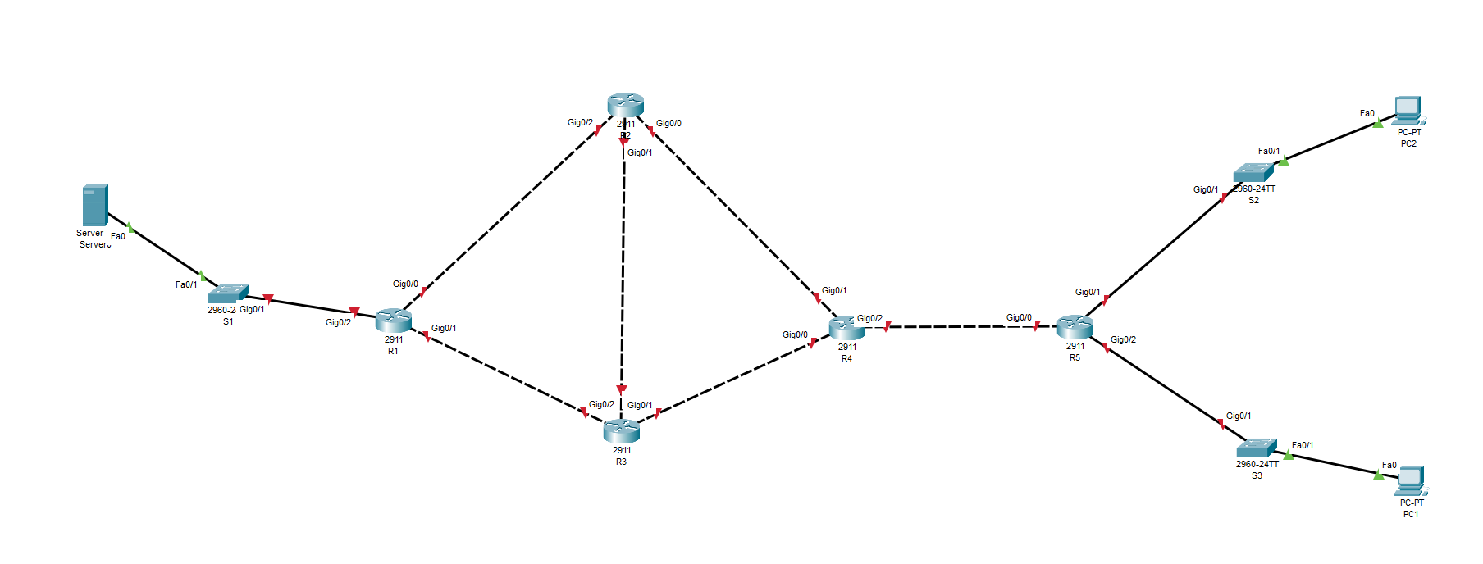

**Note**: You can display the port labels by mousing over the connection or by going to **Options 🡪 Preferences** and tick **Always show Port Labels in Logical Workspace.**

Once the topology is finished, we can proceed with the router configuration. To start, we click on **R1** and navigate to the **CLI** tab. We click next to the dialogue prompt and type **no**, then press enter. We type **enable** to enter privilege mode and then **configure terminal** to enter terminalconfiguration mode.

Notice that even though we had set the name of the router to be **R1**, the internal name of the device remains the default **Router**. To fix this, once we have entered **terminal configuration mode**, we type **hostname R1.** This will change the internal name of the device. We will do this for every router. The same procedure will be followed to configure the switches.

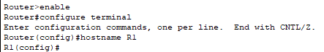

Now we will configure the interfaces of the router, using the following table.

|  |  |  |  |
| --- | --- | --- | --- |
| ***Router*** | ***Router Port*** | ***IP Address*** | ***Subnet Mask*** |
| R1 | Gi0/0 | 10.0.1.1 | 255.255.255.0 |
| R1 | Gi0/1 | 10.0.2.1 | 255.255.255.0 |
| R1 | Gi0/2 | 10.0.7.1 | 255.255.255.0 |
| R2 | Gi0/0 | 10.0.3.1 | 255.255.255.0 |
| R2 | Gi0/1 | 10.0.4.2 | 255.255.255.0 |
| R2 | Gi0/2 | 10.0.1.2 | 255.255.255.0 |
| R3 | Gi0/0 | 10.0.4.1 | 255.255.255.0 |
| R3 | Gi0/1 | 10.0.5.2 | 255.255.255.0 |
| R3 | Gi0/2 | 10.0.2.2 | 255.255.255.0 |
| R4 | Gi0/0 | 10.0.5.1 | 255.255.255.0 |
| R4 | Gi0/1 | 10.0.3.2 | 255.255.255.0 |
| R4 | Gi0/2 | 10.0.6.2 | 255.255.255.0 |
| R5 | Gi0/0 | 10.0.6.1 | 255.255.255.0 |
| R5 | Gi0/1 | 10.0.8.1 | 255.255.255.0 |
| R5 | Gi0/2 | 10.0.9.1 | 255.255.255.0 |

For interface **Gi0/0** of **R1** we take the following steps:

* Enter **terminal configuration mode.**
* Enter the **interface configuration mode** by typing **interface**, followed by the name of the interface (i.e., **interface Gi0/0**).
* Type **ip address**, followed by the desired **ip address** and **the subnet mask** separated by spaces (i.e., **ip address 10.0.1.1 255.255.255.0**)
* Type **no shutdown** to enable the interface.
* Type **exit** to return to **terminal configuration mode**.

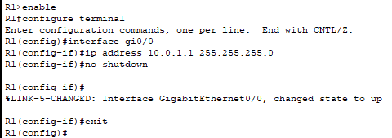

Follow the same procedure to configure all interfaces as shown in the table. If everything was setup correctly you should not see any red arrows in your topology.

Now we will setup **RIP** on routers 1-4. Since **R5** can only route packets in a single path towards **R4**, it does not require dynamic routing. Thus, we will set a static route between **R5** and **R5**.

To setup **RIP** on **R1** we take the following steps:

* Enter **terminal configuration mode**.
* Type **router rip** to enter the **protocol configuration mode**.
* Type **version 2** to set the version of **RIP**.
* Type **network 10.0.0.0** to include all class A networks in the RIP routing process.
* Type **no auto-summary** to disable automatic route summarization.
* Type **exit** to return to **terminal configuration mode**.

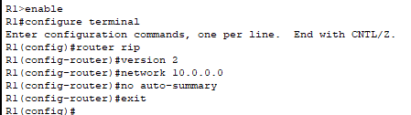

We follow the same procedure to setup routers **R2** and **R3**. Since **R4** will also contain a static route, we need to add the command **redistribute static** in order to ensure that **RIP** advertises the static route.

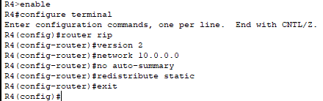

**Note:** The project instructions tell us to establish the static routes on **R5**; however, I believe this is false. Since **R5** is already physically connected to **S2, S3** and **R4**, it automatically knows where to forwards all traffic. **R4**, on the other hand, is not aware of networks **10.0.8** and **10.0.9** and so it needs a static route to know where to forward the traffic coming from these networks.

To create the static routes on **R4** we take the following steps:

* Enter **terminal configuration mode**.
* Type **ip route 10.0.8.0 255.255.255.0 10.0.6.1** to establish the static route that will forward all traffic intended for network **10.0.8** to interface **Gi0/0** of **R5** that has the ip address **10.0.6.1**.
* Type **ip route 10.0.9.0 255.255.255.0 10.0.6.1** to establish the static route that will forward all traffic intended for network **10.0.9** to interface **Gi0/0** of **R5** that has the ip address **10.0.6.1**.
* Type **exit** to return to **terminal configuration mode**.

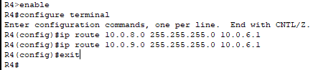

Finally, we will add a default static route to **R5** that will redirect any unknown traffic to **R4**. To do this we type **ip route 0.0.0.0 0.0.0.0 10.0.6.2** after entering **terminal configuration mode**.

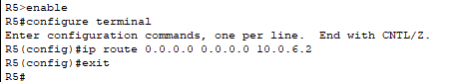

To enable automatic ip address assignment using **DHCP** on **R5** we take the following steps:

* Enter **terminal configuration mode**.
* Type **ip dhcp excluded-address 10.0.9.1 10.0.9.5** to exclude the first range of addresses as required by the instructions.
* Type **ip dhcp excluded-address 10.0.8.1 10.0.8.5** to exclude the second range of addresses as required by the instructions.
* Type **ip dhcp excluded-address 10.0.8.40 10.0.8.50** to exclude the third range of addresses as required by the instructions.
* Type **ip dhcp pool HR** to create the first required pool, name it and ender its **configuration mode**.
* Type **network 10.0.9.0 255.255.255.0** to set the network range covered by this pool.
* Type **default-router 10.0.9.1** to set the default gateway for all devices in the pool. We use the ip of the interface **Gi0/2** of **R5** as the default gateway.
* Type **exit** to return to **terminal configuration mode**.
* Type **ip dhcp pool PRODUCTION** to create the first required pool, name it and ender its **configuration mode**.
* Type **network 10.0.8.0 255.255.255.0** to set the network range covered by this pool.
* Type **default-router 10.0.8.1** to set the default gateway for all devices in the pool. We use the ip of the interface **Gi0/1** of **R5** as the default gateway.
* Type **exit** to return to **terminal configuration mode**.

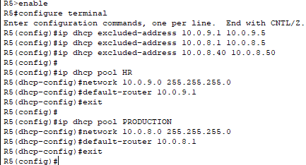

Now **R5** is able to assign an ip to any device; however, the device needs to request it. To set a pc to request an ip, we click on it, go to the **Config.** Tab, and click on the **DHCP** radio button under **Gateway/DNS IPv4** in **Global Settings**.

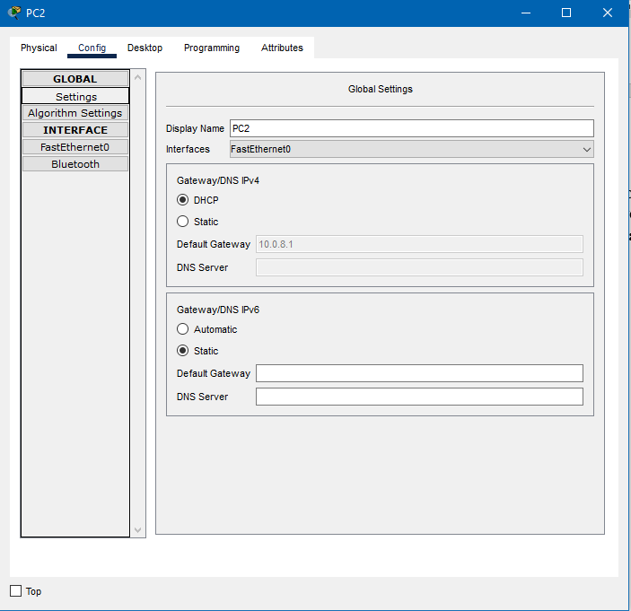

To configure the **server**, we take the following steps:

* Move to the **Config.** Tab and change the Display Name to Web Server under **Global Settings**
* Change the **Default Gateway** to 10.0.7.1 to match interface **Gi0/2** of **R1**.  
  **Note:** The instructions state that the default gateway should already be set from Task 1; however, I see no reason for this.
* From the lefthand menu click on **FastEthernet0** under the **INTERFACE** category.
* In the **IPv4 Address** box, under **IP Configuration**, type **10.0.7.2** and in the **Subnet Mask** box directly below type **255.255.255.0**.
* Close the configuration window.

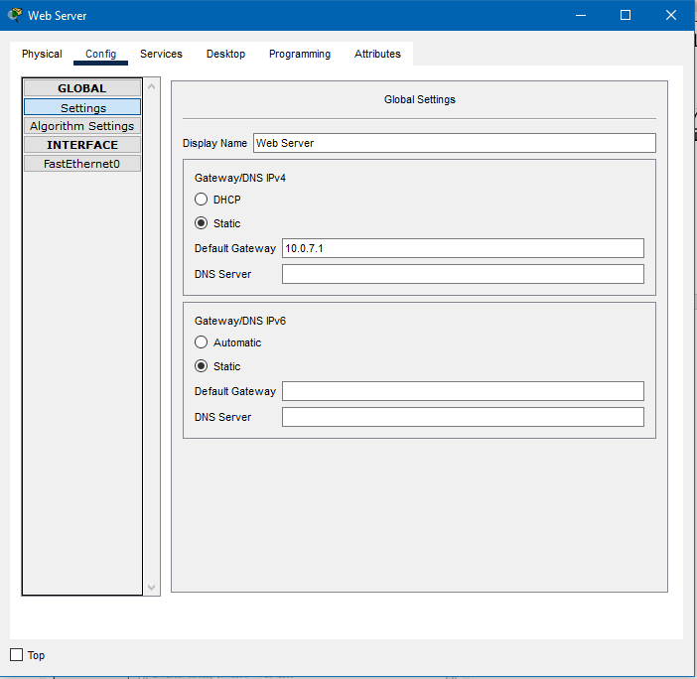

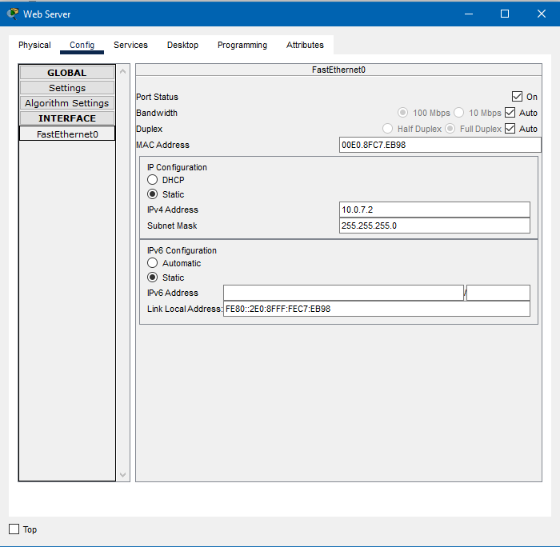

All done! To test the network, try pinging the **Web Server** from **PC1**. To do this we click on **PC1**, move to the **Desktop** tab, click on **Command Prompt**, and type **ping 10.0.7.2**. The first request might time out due to the construction of the routing tables; however, if two or more packets echo successfully everything is good!

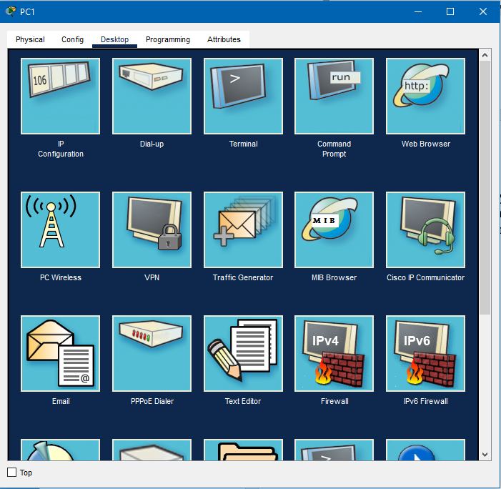

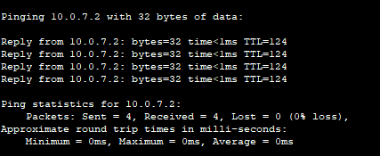

Thank you for following this tutorial! If you faced any issues during the process figure it out yourself, please don’t bother us!